**公司6月份生日會**

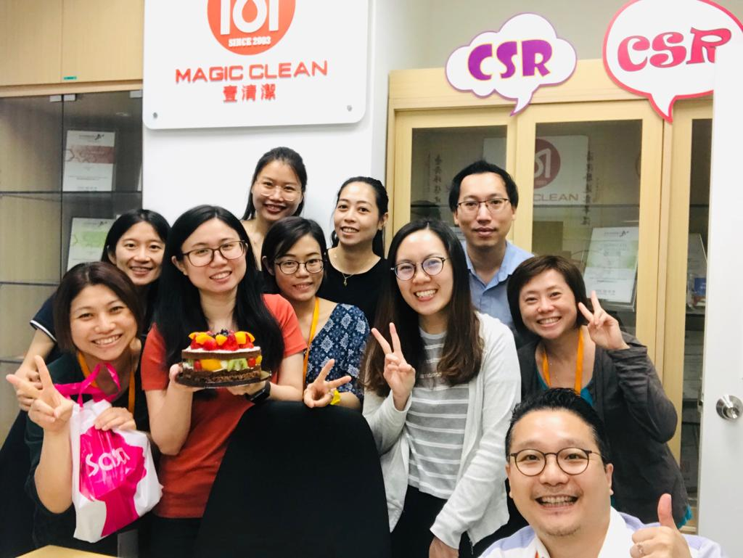

員工為公司重要資產，Magic Clean 為6月份生日的同事舉辦生日會，感謝僱員的努力。

Employees are important assets of the company, and Magic Clean held a birthday party for colleagues in the June birthday, thanking employees for their efforts.